Architecture Design Document
Self-Service VM Provisioning & Guest Customization on VCF 9.1
Solution: Self-Service VM Provisioning & Guest Customization
Platform: VMware Cloud Foundation 9.1 (VCFA, vRO, vSphere, Service Broker)
Document version: 1.0
Date: June 2026
Audience: Customer stakeholders (business & operations)

1. Architecture Overview
The solution is an event-driven extensibility pattern on VCF 9.1. Users consume a Service Broker catalog item; VCFA provisions the VM and emits a Compute post-provision event; an Extensibility subscription routes that event to a vRO workflow that performs OS-specific customization in the guest or on the VM shell.
Two independent pipelines share the same trigger mechanism, differentiated by OS type:
- Windows pipeline — customizes a fully deployed guest OS (mature, tested).
- Linux pipeline — prepares a VM shell for OS installation from ISO media (in development).

1.1 Components
Component | Role
VCF Automation (VCFA) | Self-service consumption, provisioning engine, Extensibility event broker.
Service Broker | Catalog presentation and request intake with custom input forms.
VCF Operations Orchestrator (vRO) | Executes customization workflows and actions; holds all automation logic and credentials.
vSphere / vCenter | Underlying compute; target of VM reconfigure and guest operations.
ESXi hosts | Host guest operations and file transfers; SSL trust required in vRO.

1.2 Module Namespaces
Namespace | Contents
com.broadcom.pso.vcfa.customforms | Custom form actions (e.g. ISO list, cluster list).
com.broadcom.pso.vcfa.vm.guestScripting | Guest script upload and execution helpers.
com.broadcom.pso.vcfa.vm.diskManagement | Disk UUID extraction and disk operations.

2. Data Flow & Interactions

2.1 End-to-end sequence
- User selects a catalog item in Service Broker and completes the input form (OS type, disks, ISO selection).
- VCFA provisions the VM in vSphere.
- VCFA fires the Compute post-provision event topic for the machine.
- Extensibility subscriptions evaluate their conditions against event.data.customProperties.osType.
- The matching subscription invokes its bound vRO workflow as a blocking extensibility task.
- The vRO workflow connects to the VM and performs OS-specific customization.
- On success the workflow returns; VCFA marks the deployment complete. On failure VCFA destroys the VM.
Design note — guest-readiness gate
Blank/imageless VMs never reach compute.provision.post because VCFA waits for a VMware Tools / guest-readiness signal that a no-OS VM never produces. The Linux pipeline therefore deploys a throwaway OS template to satisfy the guest-up gate, then reshapes the VM (power off, recreate boot disk as blank, attach ISO, boot) in post-provision.

2.2 Event routing logic
Both subscriptions bind to the same event topic and discriminate on OS type using a topic filter condition:
// Windows subscription condition
event.data.customProperties.osType == "windows"

// Linux subscription condition
event.data.customProperties.osType !== "windows"

3. Extensibility Subscriptions
Subscriptions are configured under Extensibility → Subscriptions in VCFA. Both subscribe to the Compute post provision topic, are blocking, and invoke a workflow-based action.

3.1 Windows: “Customize Windows OS”
- Event topic: Compute post provision (blockable; publisher: Provisioning).
- Condition: event.data.customProperties.osType == "windows"
- Action/workflow: Customize Windows VM Guest (workflow-based extensibility).
- Blocking: Enabled. Timeout 0 (no override). Priority 10.
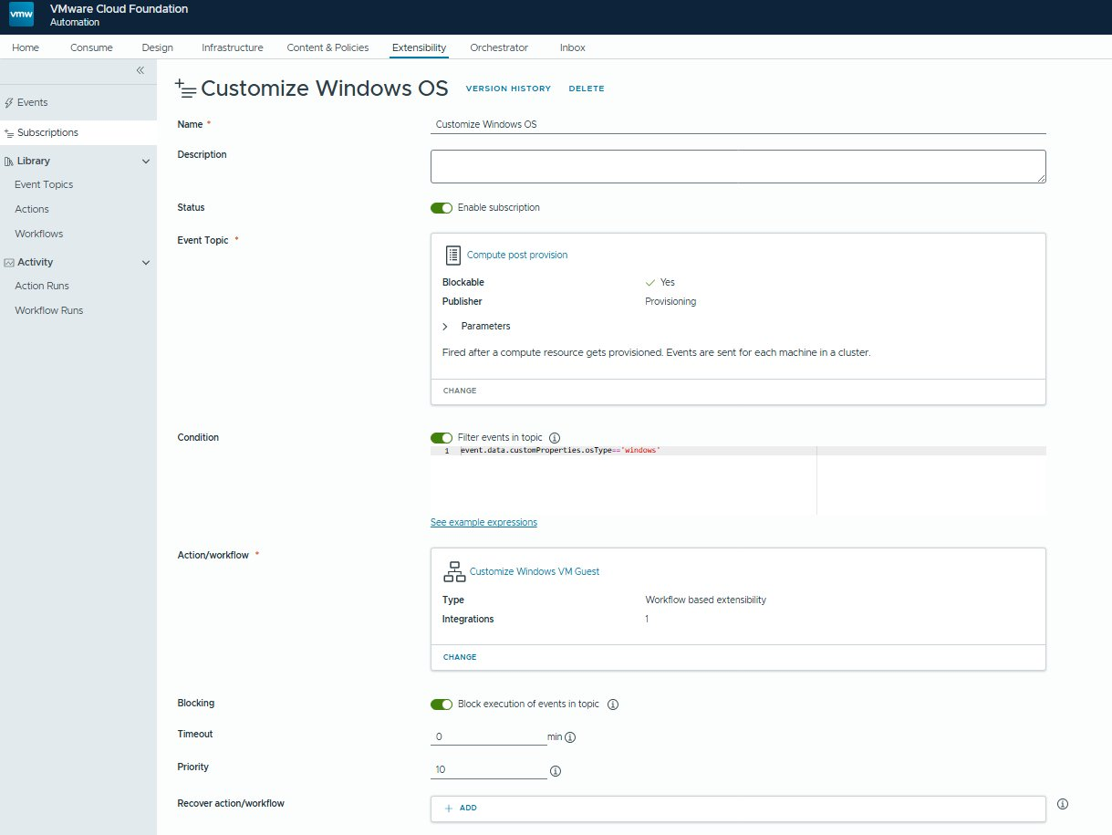
Figure 1 — VCFA Extensibility subscription: Customize Windows OS

3.2 Linux: “Prepare Linux Shell VM”
- Event topic: Compute post provision (blockable; publisher: Provisioning).
- Condition: event.data.customProperties.osType !== "windows"
- Action/workflow: Prepare Linux VM Shell (workflow-based extensibility).
- Blocking: Enabled. Timeout 0. Priority 10.
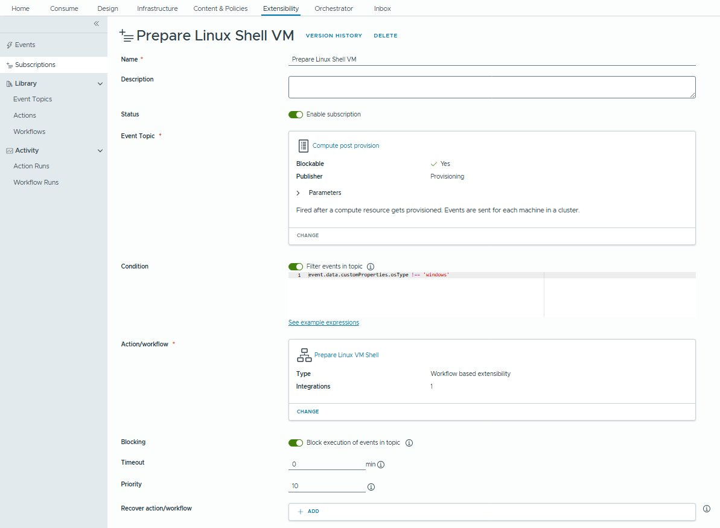
Figure 2 — VCFA Extensibility subscription: Prepare Linux Shell VM

4. Windows Pipeline Design
The parent workflow chains four child workflows in sequence, supported by reusable actions.

4.1 Workflow chain
Order | Child workflow | Function
1 | Configure CD Drive Letter | Sets the guest CD-ROM drive letter to free a target letter for data disks.
2 | Rename Windows Local Admin | Renames the built-in local Administrator account to the standard name.
3 | Change Local Account Password | Sets the local account password from a secured input.
4 | Mount/Format Disks Windows | Initializes, formats, and mounts attached data disks by UUID match.
Parent workflow: Customize Windows VM Guest (WF ID 7f97799b).

4.2 Supporting actions
Action | Module | Purpose
utf8ByteLength | guestScripting | Returns UTF-8 byte count for guest file transfer sizing.
uploadGuestScript | vm.guestScripting | Uploads a script to the guest for execution.
extractDiskUUIDs | vm.diskManagement | Extracts VMDK UUIDs for guest-side disk matching.

4.3 Key platform behaviors enforced
- Template prerequisite disk.EnableUUID = TRUE is mandatory and gated by an assertion before disk operations.
- Windows Get-Disk SerialNumber exposes VMDK UUIDs without dashes and lowercase; both sides are normalized before matching.
- dataDisks from VCFA custom properties arrives double-encoded and is parsed with a string-type check and double JSON.parse.
- File transfer size uses UTF-8 byte count, not JS character length.
- VCFA-generated customization specs blank the local Administrator password during sysprep on linked-clone deployments; the password is set explicitly in the guest customization spec.

5. Linux Pipeline Design
The Linux pipeline prepares a VM shell so an OS can be installed from ISO media. It works around the guest-readiness gate (Section 2.1) by deploying a throwaway OS template, then reshaping the VM.

5.1 Workflows and actions
Element | Type | Function
getIsoList | Custom form action | Returns tree-ordered full datastore ISO paths for the selected vCenter/cluster.
Attach ISO to CD Drive | Workflow | Power off, mount ISO as CD-ROM, power on.
RecreateBootDisk | Workflow | Deletes the existing boot disk and recreates it as a blank disk.
Linux shell VM cloud template | Blueprint | Defines the deployable shell VM.

5.2 Key platform behaviors enforced
- Cluster resolution tries getAllResourcePools() first and climbs .owner; falls back to getAllClusterComputeResources().
- vCenter matching uses connection.sdkId (FQDN); cluster matched by name string.
- Disk capacity property is capacityInKB (capitalization is significant).
- SCSI controller lookup must check four concrete subclasses (VcParaVirtualSCSIController, VcVirtualLsiLogicSASController, VcVirtualLsiLogicController, VcVirtualBusLogicController); the abstract type does not match in the plugin context.
- Boot-disk recreation uses two separate reconfigVM_Task calls (delete, then recreate).
- Power-off is awaited as a task, not fire-and-forget, before reconfigure.

6. Dependencies
- VCF 9.1 with VCFA, vRO, and Service Broker operational and integrated.
- vCenter and ESXi endpoints registered in vRO; ESXi self-signed certificates imported into the vRO SSL Trust Manager (required for ESXi-hosted URL file transfer to guest).
- VM templates with required settings (disk UUID enablement, SCSI assignment) available in vSphere.
- A vRO Configuration Element holding all credentials (no hardcoded values in code).
- VMware Tools present in deployed templates to satisfy the guest-readiness gate.

7. Assumptions
- VCFA emits osType in event custom properties for all in-scope catalog items.
- Network, storage, and security policies are provided by existing VCF platform standards.
- Deployments that fail are destroyed by VCFA and re-requested by the user (no in-place retry).
- Datastore ISO media is pre-staged and accessible to target clusters.

8. Risks & Mitigations
Risk | Mitigation
Linux pipeline not yet end-to-end tested. | Complete lab validation before production enablement.
Lab-specific cluster lookup (getAllResourcePools) unsuitable for production scale. | Switch getClusterList to getAllClusterComputeResources at cutover.
Blueprints use direct image references rather than linked-clone for production. | Switch blueprints from image: to imageRef: at cutover.
Admin password sourcing undecided (org-wide Secret vs per-deployment). | Pending security team input; document final decision before go-live.
Missing template prerequisites cause guest operation failures. | Pre-flight assertions gate execution (e.g. disk UUID enablement).

9. Security Considerations
- All credentials are stored in a vRO Configuration Element; no credentials are hardcoded in workflow or action code.
- VCFA Secrets mapped to VM custom properties appear in plain text in the extensibility payload (inputProperties.customProperties); treat this payload as sensitive and restrict run-history access accordingly.
- VcNamePasswordAuthentication.interactiveSession is explicitly set to false for all guest authentication.
- ESXi certificate trust is established deliberately via the vRO SSL Trust Manager rather than disabling validation.
- Workflow run logs are restricted; no credential values are written to logs (verify before each package release).

10. Operational Considerations
- Workflows are organized under Library / Production / VCF Automation / VM Deployments, with helpers under .../Helpers.
- vRO exports (.yml) are the source of truth; annotated .js files are the human-readable reference, kept in sync element-by-element.
- Prefer officially documented APIs only; validate against vroapi.com or Broadcom TechDocs before adopting any method.
- Destroy-on-failure semantics keep state clean; idempotent re-run is intentionally deferred.
- Changes are delivered as targeted element-level updates to ease review and reduce regression risk.

